VEERAPANDIYAN P
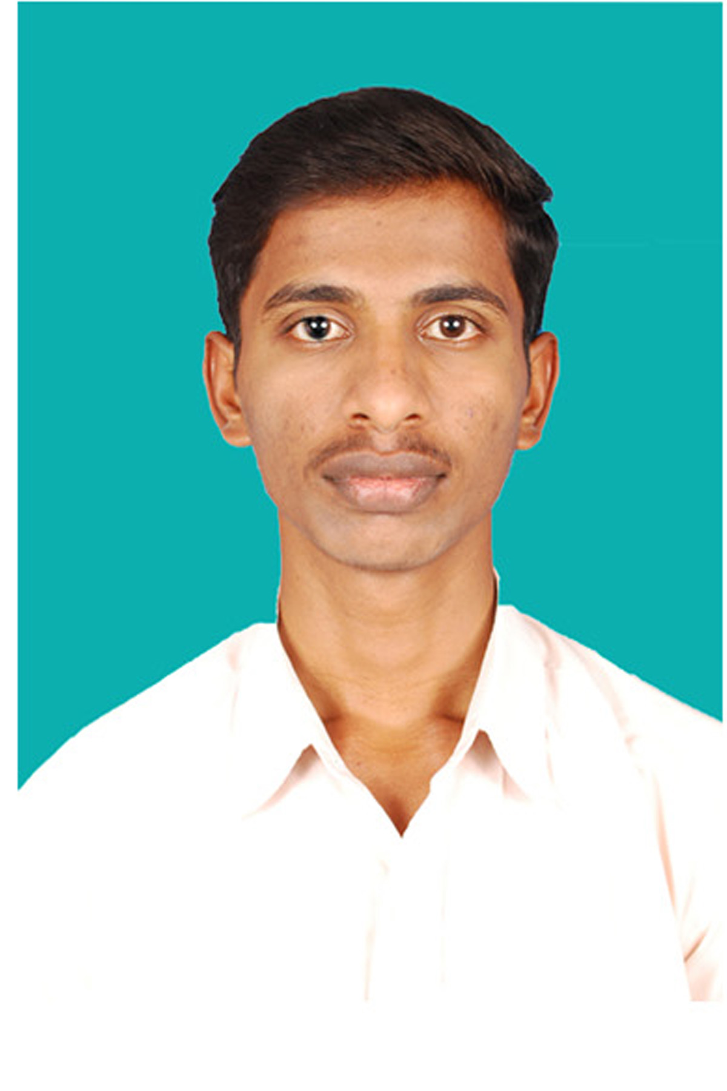
: +91-8056044518
: veeraatshc@gmail.com

A qualified Computer Science graduate, aiming for assignments in Mobile and Web Application Development & Design / Testing with a reputed organization in IT sector

PROFILE SUMMARY

- Have 8 years of experience in programming with Web Application using IONIC, Angular, HTML5, CSS3, JavaScript, PHP and PostgreSQL.
- Well versed with IONIC, Angular, HTML5, JavaScript, CSS3, XML, JSON, PHP and PostgreSQL.
- Experience in adapting visual designs into dynamic websites and designing & optimizing graphics for client sites
- Holds the distinction of working on Web Based Projects and evaluation, testing & improvement of websites
- Skilled in interacting with team members to ensure smooth progress of project work
- Capable in creating web services and web applications
- Ability in handling multiple priorities with a bias for action and a genuine interest in personal & professional development
- An ambitious & hardworking individual with excellent problem solving skills and the ability to manage time effectively

IT SKILLS

Languages : HTML5, PHP, XML and JSON
Script Languages : JavaScript, Angular and CSS3
Database : PostgreSQL
Operating Systems : Windows, Linux
Tools : Geoserver, QGIS and ArcGIS
Framework : Ionic 5
Text Editors : Visual studio code, Notepad++ and Sublime.

ORGANIZATIONAL EXPERIENCE

I have worked in the following projects using IONIC with Angular, HTML5, CSS3, JavaScript, XML, JSON, JQuery, Angular, PHP, Openlayers, Leaflet, GeoServer, and PostgreSQL/PostGIS.

Title: Integrated Road Accident Database (iRAD)
Synopsis: The main objective of the project is development of Integrated Road Accident Database (iRAD), to enrich the accident databases from every parts of the country. The project would generate various types of insights by analyzing the collected road accident data across the country through implementation of data analytics technique. The proposed system would represent the analysis output through Monitoring & Reporting Dashboard & Analytics Dashboard for easy understanding and accordingly forecasting & Decision Making by Apex Authorities for formulation of new policies & strategies. The outcome of the project would be enhanced road safety i.e. ‘Safe Road for All’ in India.

Employer: Velocis Systems Pvt Ltd, Client : MoRTH, Duration : 2020- upto date
SISL Infotech, Client : MoRTH, Duration : 2019- 2020

Responsibilities:
- Database Design.
- Creating APIs.
- Creating Mobile and WEB Application.
- Enabled role based authentication for view maps and data.

Title: Tamil Nadu Geographical Information System (TNGIS)
Synopsis: Tamil Nadu Geographical Information System (TNGIS) is conceived with an ultimate objective to create a generic model of GIS and to easily integrate with other available data sets. The Geographical Information System (GIS) is a tool for managing, analyzing, decision making by seamlessly combining both spatial and non-spatial data. In Tamil Nadu, a vast spatial data have been generated through GIS Projects undertaken by several Departments. This will provide a uniform GIS platform over the State. Geographical Information is necessary to take decisions in various Government Departments as well as providing services to the citizens. It is proposed to establish a Digital Maps Repository which would serve these purposes
Responsibilities:
- Created services for spatial data with different styles and formats.
- Created user interfaces to brows all maps both department users and public.
- Created user interface for public to create their own thematic map based on their data.
- Enabled role based authentication for view maps and data.
- Enabled print option of maps with user friendly option.

Employer: SISL Infotech, Client: TNEGA, Duration: 2015-2019

Title: Chennai Metropolitan Development Authority (CMDA)
Synopsis: Chennai Metropolitan Development Authority (CMDA) is responsible for issuing Building Plan Permission Approvals, Layout and Subdivision approvals for the citizens and builders for taking up construction within the jurisdiction of Chennai Metropolitan Area (CMA). Web interface for viewing the maps/spatial database shall show Catchment areas, CRZ, IAF and other restricted areas appropriately. GIS integration would enforce the right decision support system on Planners’ desktop for easy scrutiny of the site.

Responsibilities:
- Created an interface for Editing of Attribute Data for CMDA Land use maps.
- Local body, Village and Survey Number search Facilities are enabled for CMDA Application.
- Added an option for Buffer Analysis based on CMDA Data.
- Added an option for Drilldown and Enable Print Option.
- Query for Area, Land wise, Street alignment, Special Categories like CRZ, IT corridor, ARA, RCA, EWS, MRTS, Reclassification, Layout Approved extra provision provided.
- Buffer Search- Buffer is drawn based on the selection of survey number with centroid or a selected parcel.

Employer: Silver Touch Technologies Limited, Client : CMDA, Duration : 2014-2015

Title: GIS for Ponneri TownPanchayat(GIS)
Synopsis: The main aim of this project is to create GIS Database, generate various Maps to compare and prepare various report for the existing data (Property Tax, Water Tax) with survey data.

Responsibilities:
- Programmatically extract the following Layers from the Satellite Imagery: Town Panchayat Boundary, Buildings, Roads, Water Bodies, etc. and these data maintained in Postgres database.
- Adding attributes to the features extracted from the imageries (like names, types, etc. of roads, water bodies, etc.)
- Building Search by door number and match with Property tax, water tax and
- Preparation of various reports.

Employer: Neelkanth Digital Infonet Private Limited, Client : TNEGA , Duration : 2013-2014

ACADEMIC QUALIFICATIONS

2013 MCA with 78% from Anna University, Chennai.
2010 B.Sc. (Computer Science) with 68% from Sacred Heart College, Tirupattur.
2007 XII with 72% from IVN Government Higher Secondary School, Gajalnayakanpatti.
2005 X with 73% from Jothi High Secondary School, Jothi Nagar.

PERSONAL DETAILS

Date of Birth 4th April, 1990
Address S/O P. Periyasamy, Aniganoor, Gummidigampatti, Tirupattur – 6035901
Languages Known English & Tamil

DECLARATION

I feel that I would bring a resourcefulness of years of experience in a wide range of discipline having good work ethic and the capability, and I hereby declare that the above details are true to best of my knowledge and I am personally responsible for the authenticity of the same.

Place: Chennai 
Date: 28/10/2021 (VEERAPANDIYAN P)

